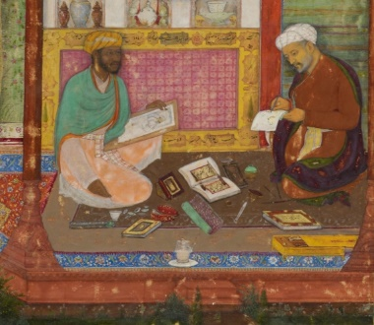 | Workshop on Sources:  Quotation, Paraphrase, Citation: Horror Stories and Best Practices! | 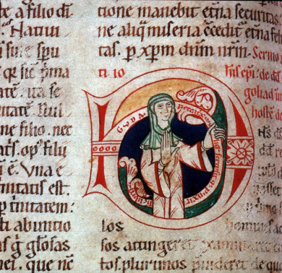
Portrait from the Khamsa of Nizami - BL Or. MS 12208 f. 325 Staatsbibliothek, Frankfurt MS Barth. 42 (12th c.)
ksawyer@mccormick.edu www.kennethsawyer.org
RESOURCES:
- https://www.plagiarism.org/understanding-plagiarism
- Indiana University plagiarism tutorials and tests: https://plagiarism.iu.edu/index.html
- Links to writing centers and resources, gathered by Howard Community College Writing Center: https://www.howardcc.edu/services-support/academic-support/learning-assistance-tutoring/howl-online-writing-lab/
- Citations: a short intro to notes/bibliography format, by U. of Wisconsin Writing Center: https://writing.wisc.edu/handbook/documentation/docchicago/notes-bibliography/
- How Senator Walsh plagiarized his thesis: https://www.nytimes.com/interactive/2014/07/23/us/politics/john-walsh-final-paper-plagiarism.html
- HHS Office of Research Integrity standards: https://ori.hhs.gov/avoiding-plagiarism-self-plagiarism-and-other-questionable-writing-practices-guide-ethical-writing
- McCormick Seminary policy on proper use of sources and responses to misuse and plagiarism – pp. 44-47 of the McCormick Academic Catalog at: https://static1.squarespace.com/static/5fd4065a674bc6778f3da855/t/615c758d2e5e4e1fe4ba9023/1633449358175/Academic+Catalog+2021-2022+-+final.pdf
- Go and do not do likewise: stories of plagiarism and pain: https://noogatoday.6amcity.com/resignation-of-tennessee-temple-president-rooted-in-past-plagiarism/

Examples of misuse:
Example ONE:
Original text [Shelley, p. 184]: The gift made the pope a temporal ruler over the Papal States, a strip of territory that extended diagonally across Italy from coast to coast.
Student paper: The gift made the pope a temporal ruler over the Papal States, a strip of territory that extended diagonally across Italy from coast to coast.

Example TWO.
Original text [Gonzalez, p. 281]: The word pope simply means “Father,” and in early times was used to refer to any important and respected bishop. Thus, there are documents referring to Pope Cyprian or Carthage, or to Pope Athanasius of Alexandria. In the West the title was eventually reserved for the bishops of Rome, but in the East it continued to be used with more liberality. In any case, what is important is not the origin of the title of pope, but rather how the bishop of Rome came to enjoy the authority that he had in the middle ages, and still has in the Roman Catholic Church.
Student paper: The word pope simply means “Father,” and in early times was used to refer to any important and respected bishop. Thus, there are documents referring to Pope Cyprian or Carthage, or to Pope Athanasius of Alexandria. In the West the title was eventually reserved for the bishops of Rome, but in the East it continued to be used with more liberality. In any case, what is important is not the origin of the title of pope, but rather how the bishop of Rome came to enjoy the authority that he had in the middle ages, and still has in the Roman Catholic Church.

Example THREE:
Original text [Gonzalez p. 274 and 277]: At the same time as some of the various Germanic invasions were taking place, the Irish church was flourishing. Since it retained much of its earlier faith and culture, Ireland soon began sending missionaries to other countries, most notably to Scotland. The most famous of these missionaries was Columba, who settled on the small island of Iona with twelve companions, probably in 563 ce. The monastery that they founded there became a center of missions to Scotland…
Student paper: Around the time of the Germanic invasions the Irish churches were flourishing… Retaining the culture and faith of earlier Christian movements, Ireland began sending missionaries to Scotland. The missionary Columba settled on the small island of Iona with twelve companions around (563) and founded the monastery that eventually became the center of missions for all of Scotland.

Paraphasing and plagiarizing

Here is how one site presents the topic:

How similar is too similar?

When does similarity become plagiarism?
Published February 27, 2018 at https://www.plagiarism.org/blog/2018/02/27/how-similar-is-too-similar
When many students first start learning about plagiarism and citation, one of the first questions they often ask is “How similar is too similar?”
Unfortunately, this question, while understandable, isn’t very helpful when trying to understand plagiarism. Plagiarism is about citation, not duplication, and it’s possible to use passages of text verbatim without plagiarism as long as it is quoted and cited correctly.
Often times, the question is asked with reference to paraphrasing: When is a work changed enough so that it doesn’t need to be quoted but can be considered original?
However, once again, the question isn’t very helpful. Paraphrasing isn’t about changing the words of the original source, but about writing the ideas in your own words. If you’re paraphrasing correctly, none of the original verbiage should be present.
In short, when writing an essay, there’s no time in which you should be altering the words of a source in hopes of making them original. Anything copied from the source should be quoted and cited accordingly and all other writing should be as original as possible.
But that doesn’t mean that any matching text is automatically a case of plagiarism. In fact, a 0% matching score is often as suspicious as a high percentage matching.
This is because even if two essays are written completely independently, there’s a good chance that they will have some overlapping text between them. This is especially true if they are written on the same topic.
This includes common phrases, relevant expressions, cliches and even some passages that may only have one way to say it properly.
In short, matching text, by itself, is not an indication of plagiarism. To determine if matching text is plagiarism a human needs to evaluate that the text was copied inappropriately and not cited correctly.
Plagiarism detection services are powerful tools, but they are meant to aid human evaluation, not replace it.
That being said, it’s also possible to plagiarize without copying text at all. One can plagiarize ideas and information just as easily as they can text. So having information and ideas that are not common knowledge but not cited can also be plagiarism.
What that means is that, even if your words are original, your work can still be a plagiarism if your ideas and information are not and are not cited.
While this may seem frightening and like there are infinite ways to fall into the “trap” of plagiarism, the solution is actually very simple: Citation.
As long as you do your own writing and cite your information as well as any quotes you use, you should be fine.
After all, the golden rule of avoiding plagiarism is this: When in doubt, cite!
If you follow the golden rule, you should be fine.
(from https://www.plagiarism.org/blog/2018/02/27/how-similar-is-too-similar)

I think the key quote from this essay on paraphrasing is here:
“In short, when writing an essay, there’s no time in which you should be altering the words of a source in hopes of making them original. Anything copied from the source should be quoted and cited accordingly and all other writing should be as original as possible.”
This quotation makes two central points for all of us: if you are changing a text by moving words and clauses, by finding some creating rewording, then you are altering the source text in an attempt to make that source text into something that is yours – but it [still] isn’t yours! The resulting text is neither true to the original nor expressive of your ideas. The second point is that all the ideas and places you encountered should be documented so that your reader can find what you found!

Examples of paraphrase plagiarism: original source on left, student paper on right:
Example A:
Augustine was born in 354 CE, in the little town of Tagast, in North Africa. His father was a minor Roman official who followed the traditional pagan religion, But his mother, Monica, was a fervent Christian. | Born in 354 ce in a small town called Tagast, in North Africa, Augustine’s parents consisted of his father who was a minor Roman official that followed the traditional paganism, and his mother, named Monica, who was a passionate Christian

Example B:
That search led the young student to Manichaeism. This religion was Persian in origin, having been founded by a certain Mani in the third century. According to Mani, the human predicament is the presence in each of us of two principles. One, which he calls light, is spiritual. The other, darkness, is matter. | Seeking the truth led Augustine to Manichaeism, a religion of Persian origin. Manichaens based their belief on two principles, the light which is spiritual and the darkness which is matter. They believed the present human condition was a result of these two mixing and salvation…

Example C:
According to his own report he lived a wild life and in adolescence ‘ran wild with lust.’ He also remembered lying to his teachers and parents | According to his report Augustine used to live a “wild life” and in adolescence ‘run wild with lust,’ he lied to his teachers, parents…

Example D:
Biographers have given us but little information about her early life. And we are probably safe in assuming that she received the greater part of her early education from her father. | Biographers have not been able to provide much information about her early life. It is safe to assume that much of her early life and education came from her father.

Gonzalez, chapter 27, pages 281-282.
Gonzalez, p. 274.

